Design Research



Date : 15.04.2022

Version : 0.2

Authors : Aleksandar Hadzhiev and Felix Morenc

Version history

|  |  |  |  |
| --- | --- | --- | --- |
| Version | Date | Author(s) | Changes |
| *0.1* | *15.04.2022* | *Felix Morenc* | *Initial Version* |
| *0.2* | *15.04* | *Aleksandar Hadzhiev* | *Prototyping, Testing + Review and updating Define and Ideation Phase* |

Table of contents

I. Empathize 2

II. Define 4

III. Ideation 4

IV. Prototype 6

V. Testing 8

VI. Sources 11

# Empathize

At the start of this project, we were given the ability to freely select our topic and persona. After some thinking we decided upon the persona of Kara the energetic millennial, as she was someone we could personally empathize and relate with as we’re of a similar demographic: Text

As we wanted to attempt a new topic that we hadn’t tackled before, we decided upon the topic of Travel, additionally we felt that it was a topic that really fit with the persona at hand as younger people tend to desire to travel a lot more.

After some research and questioning of people who are part of the demographic of 20–25-year-old university students we found some key aspects that need to be taken into account when looking at the demographic:

* **Low Income**: As they’re students, they tend to either not have a job, or even if they do they barely make enough to make ends meet
* **Comfortable using technology**: Almost everyone has a very good grasp of technology, meaning the app doesn’t need to be excessively simplified

In addition to these, additional research online was done and some other traits of travel among the target group emerged:

* **Prefer experiences to luxury**: Generally young adults are more inclined to spend money or simply seek out experiences, as opposed to spending their time and money on something like better airline seats
* **Perform diligent research when planning/booking**: As opposed to trends in previous generations, young adults tend to consult approximately 10 sources when they plan and book their trips, as well as relying more on work of mouth
* **Rise of a “digital-nomad” style**: Young adults nowadays are very in tune with available technology, and make heavy use of services and tools on the internet and on their phone, such as Airbnb and booking flights/accommodation through their mobile devices

# Define

Now that some empathizing and research on potential areas where we could improve or contribute to the travel situation, we moved on to identifying an area of focus and defining the problem at hand. The main problem at hand is the time cost in dealing with airports, but that is not really a problem, which we could tackle, because the problem is not something an app could fix, so we were able to deduce that there really wasn’t a key area that seriously needed improving in our eyes, so we decided to instead focus on some areas where an app could provide value to the travel experience of young adults. It was concluded that a field where an app would really be of value would be in providing an affordable, as well as interactive and entertaining experience that would engage someone in the city they were visiting. After much brainstorming, the problem was narrowed down and defined into one question: “How can we provide a truly interactive tourism experience”

# Ideation

With a problem defined we decided to start by looking at apps and other products in the space that tackle a similar problem or provide a similar service. This resulted in a couple of finds of other apps:

* [Wanderlog:](https://wanderlog.com) Wanderlog is an app that provides users the ability to plan and visualize their trips in an interactive way, giving them a real visual overview of their trip
* [Digalix](https://www.digalix.com/en/product-app-tourism-interactive/): Digalix provides interactive tourism points that display travelers with information on the area they’re in such as point of interest and events, also allowing them to get the information on their phone using a QR code
* [AR Scavenger hunt game](https://overlyapp.com/blog/ideas-for-augmented-reality-treasure-hunts-tours-and-walks/): Created by Overly, an app was created for the Latvian city of Riga, where users would be able to experience an interactive scavenger hunt using AR

What we were able to quickly identify was that the approach of potentially creating a game seemed quite appealing for the target demographic. Among young adults, there’s a significant amount of people who are quite into the gaming sphere, allowing us to utilize that familiarity to create a truly interactive and enjoyable experience for them while traveling

A product that really appealed to us as well was the game GeoGuessr, which places a user in a random Google Street View location, and through using clues in their surroundings they need to identify and locate where in the world they are. Looking at this idea we started to think about how we could potentially use this as an inspiration for our product.

This led us to the idea that we eventually settled on and decided to tackle ourselves. We took on the idea of creating an app that would provide the user with a picture of an important landmark in the city they are visiting, and then asking them to locate it through the use of a hot-cold directional system, as well as making them interact with the real world to be able to locate the landmark by either asking people or using clues in their surroundings.

The idea was discussed with the teachers asked for feedback from students and when received the green light, we continued with improving its basic start. The feedback we received from our discussion with both teachers and students (target group) helped us defining the very basic core of the app and additional ideas, which will not be part of the MVP.

When it came to defining and finalizing the features of the MVP, there were many aspects which we determined that would be incredible features to add potentially with a larger development window which would not be included in the produced MVP, there were:

* **Multiplayer mode**: A mode that would put random strangers up against each other, giving them all an identical location and requiring them to beat the other participants by finding it first to be crowned the winner
* **Lunch notifications**: This feature would basically provide the user with a notification around lunchtime, asking if they’d want to play a game which would not only show them a new landmark, but would then recommend them a lunch location nearby to grab a bite to eat, further improving the interactivity of the app
* **Saving lifelines**: The idea for this feature came from a game called Triviador, where users could use or save their “lifelines” for later, which basically stacked them up, which would mean that in a beginner difficulty game a user could use multiple addition time lifelines.
* **Duo game mode**: This feature came as an idea from feedback from one of our teachers. The idea behind it is that two players could play together by starting from 2 different positions and the would give them the same location, where they could meet and for example it could be a nice restaurant and have a meal together (this feature would work better with family members).
* **Continue or stop playing** – A feature which is not well shown in the MVP, because it was a last minute idea is that the app will give more power to the user, by giving him the option of staying in the location he found or start a new game (a challenge game or a regular one). If the user decides to stay, he will be given a bit more information of the place and it’s pros.
* **Challenge game**: This feature would provide the users the option to start a very short additional game, for example a location which is withing 500 meters of them, with of course a lot shorter time.
* **Badges** – This is a feature which will work together with the other features, because it will work as a reward to the users.

While these features would have been great, we settled on focusing on delivering these features in the final version:

* Difficulty selection based on how confident the user is in their ability
* Hot/Cold indicator, which would be a bar that would let the user know whether they’re moving closer to, or further away from the location
* Lifeline system on lower difficulties that would provide the user with some hints, tips or simply additional time to find the location
* Random question system, which would only apply on higher difficulties and would give the user a question related to the city/location they’re in, allowing them a chance to get some additional time to solve the puzzle
* Timer indication together with vibration on completing the game or running out of time.
* Audio indicator when the time left is 5 seconds

# Prototype

After the ideation part we started prototyping. The prototyping of the app started early on and was combined with the ideation process. A lot of the ideas which finished the concept of our application, were not part of the first prototype. Each prototype was tested on users of the target group.

1. *First View of the App:*

* **Starting Page:**

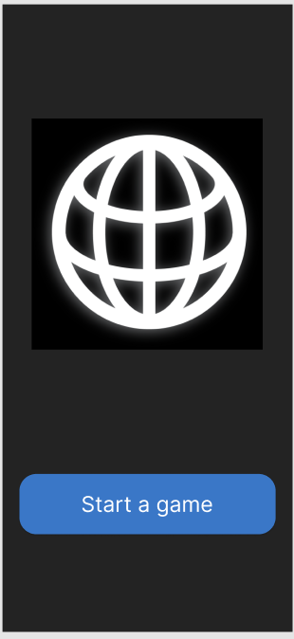

* **Game Page:**

Картина, която съдържа текст, открито, град, екранна снимка

Описанието е генерирано автоматично

1. *Second View of the App:*

* **Starting Page:**



* **Game Page:**

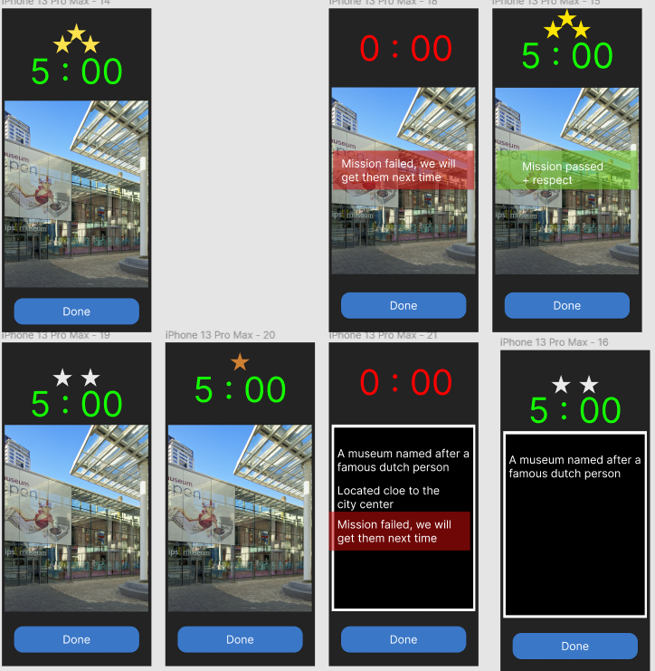

To display the hint the user had to click on the image and vice versa

1. *Final View of the App –* You can see it in the testing phase

# Testing

The testing part was combined together with our prototyping phase, because after each prototype was created we tested it and asked for feedback from users of the target group or teachers. The final form of the app is this:

* **Starting page and Difficulties page:**

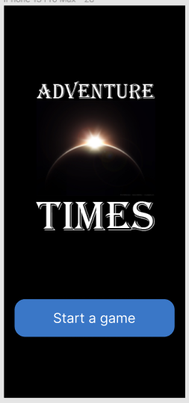Картина, която съдържа текст, небе

Описанието е генерирано автоматично

* **Beginner Page:**

Картина, която съдържа текст, знак

Описанието е генерирано автоматично

* **Semi-Pro Page:**

Картина, която съдържа текст, знак

Описанието е генерирано автоматично

* **Challenger Page:**

Картина, която съдържа текст

Описанието е генерирано автоматично

# Sources

Corrina, Cocoon, T., Aniston, J., Holly, Srivastav, S., Rossnowlagh, H. H., Davendeb, Travel, P. W., Marta, Matt, N., Audrey, Ott, S., monica530, HopandJaunt, Jennifertice, Jenkins, K., Joanne, Saskia, Gourmantic, … Gray. (2021, May 17). *Top 10 things we hate about travel*. The Planet D: Adventure Travel Blog. Retrieved April 15, 2022, from <https://theplanetd.com/top-10-things-we-hate-about-travel/>

Mohn, T. (2020, December 15). *What are young travelers up to? A new survey reveals their splurges and where they go for happiness*. Forbes. Retrieved April 15, 2022, from <https://www.forbes.com/sites/tanyamohn/2018/07/29/what-are-young-travelers-up-to-a-new-survey-reveals-their-splurges-and-where-they-go-for-happiness/?sh=733bf72154c6>

*What do people hate most about airline travel?* Quora. (n.d.). Retrieved April 15, 2022, from <https://www.quora.com/What-do-people-hate-most-about-airline-travel?share=1>

*17 reasons why around the World Travel is good for you*. AirTreks. (n.d.). Retrieved April 15, 2022, from <https://www.airtreks.com/ready/17-reasons-why-travel-is-good-for-you/>

Rodgers, G. (2019, August 14). *7 reasons traveling is good for the mind and body*. TripSavvy. Retrieved April 15, 2022, from <https://www.tripsavvy.com/how-travel-will-enhance-your-life-1458533>

Mediati, N. (2021, July 19). *Best travel apps in 2021*. Tom's Guide. Retrieved April 15, 2022, from <https://www.tomsguide.com/round-up/best-travel-apps>

Viktor Vincej·March 16, 2022, read, B. T. C. mins, & USA, T. T. (2022, March 17). *13 best travel planner apps for your next trip in 2022*. Traveling Lifestyle. Retrieved April 15, 2022, from <https://www.travelinglifestyle.net/best-travel-planning-apps/>